**Sitraffic smartTL Connect**

[Catchy phrase associated with the product and image for the cover]

**The era of Digitalization in Mobility**

We are now entering in a time where technology is at the edge of development and solutions are tailored for every challenge. The stakes have never been higher. With this in mind we strive to upgrade our products, customize them to fit our clients’ needs and deliver the best offer according to their expectations.

The Sitraffic smartTL Connect solution was developed to fulfill a need from a client. Some cities have different controllers spread in several locations. Because they don’t use the same platform it isn’t possible to have all the information in one base. The Sitraffic smartTL Connect solves this challenge by allowing our Sitraffic smartGuard to connect virtually any controller, regardless its original specifications or brand.

This solution was developed to answer to a client’s challenge to find a way to connect our cloud based central system to all of his devices with low downtime, keeping the possibility of reverting the process and compatibility with several different types of devices. In the search for a solution we identified a wider range of possibilities and applications worldwide.

**Ideally, any traffic controller should be able to communicate with any central system. But that is not the reality today.**

- With Siemens Sitraffic smartTL Connect it is now possible to connect virtually any third party controller with Siemens Sitraffic smartGuard, our cloud based traffic control center.

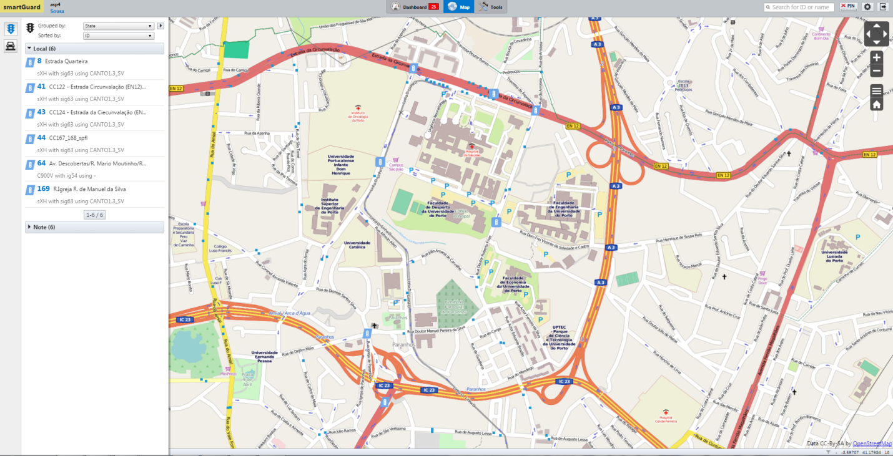

[SmartGuard Interface screenshot – see photo that I sent attached to substitute this]

With the advantages that smartGuard offers.

Sittrafic smartTL Connect allows the client, through Sitraffic smartGuard, to monitor and control the field devices regardless of the manufacturer offering operational basic functionalities such as:

Monitor Controller’s state:

* Normal mode;
* Safety mode;
* Offline;
* Power-off mode.

Control Features:

* Change between operational modes (normal and safety);
* Remote reset.

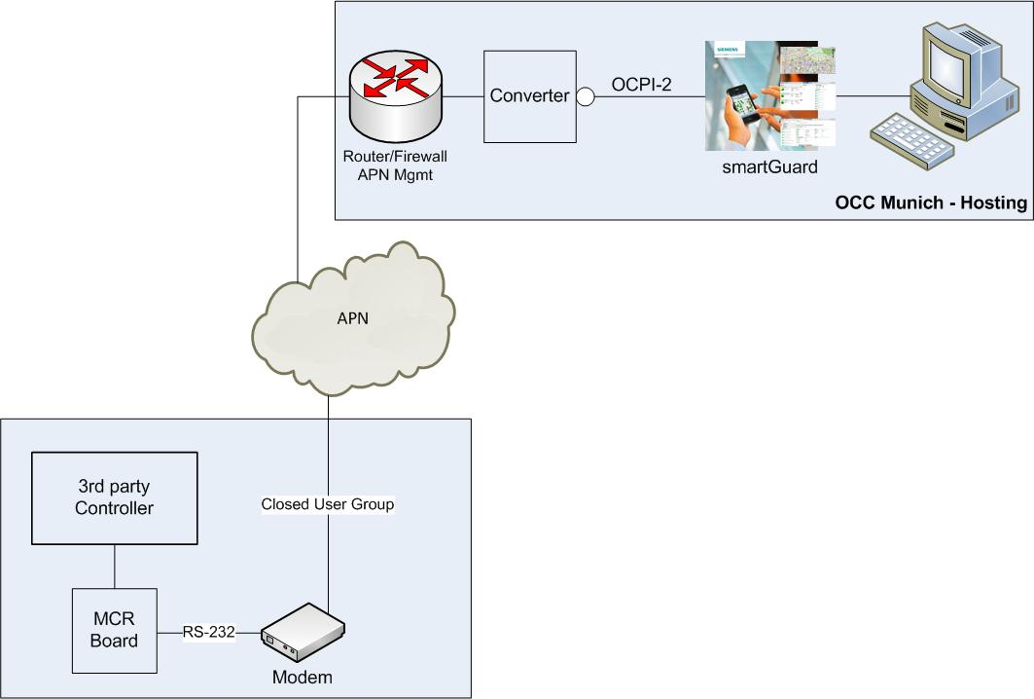

[System Architecture Picture]

Sitraffic smartTL Connect System Architecture - Our device (MCR module) allows bidirectional communication between Sitraffic smartGuard and third party controllers, through a secured mobile network connection (GPRS/3G/4G).

Simple installation, as easy as plug & play.

Unobtrusive functionality does not interfere with the controller's normal operation.

Some control features might be limited depending on the controller's model.

Advantages:

* Support to surveying processes, providing visibility on the operational performance of the installed base;
* Quickly deployment of Sitraffic smartGuard with already existing infrastructure;
* Enables immediate monitor and control features, while replacing older field devices;
* Increases productivity;
* Reduces maintenance costs.

(ver na brochura em anexo como estão estes contatos mas apliquem os novos guidelines considerando que esta é uma monofolha)

**Siemens, S.A.**

Mobility Division

Intelligent Traffic Systems

Rua Irmãos Siemens 1

2720-093 Amadora

Portugal

© Siemens 2016

All rights reserved

Printed in Portugal

Sitraffic is a registered trademark of

Siemens.

The information in this document contains

general descriptions of the technical options

available. The required features should

therefore be specified in each individual case

at the time of closing the contract. For the

secure operation of Siemens products

and solutions, it is necessary to take suitable

preventive action and integrate each component

into a holistic, state-of-the-art security

concept. Third-party products that may be

in use should also be considered.